Pentecostal Faith Assemblies, Inc.
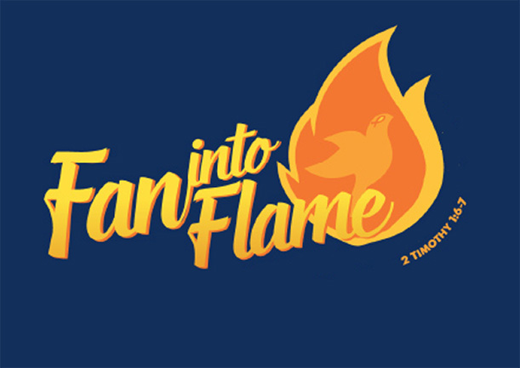
Camp Meeting

the gift of God which is in you.

June 25 – 27, 2021
Hosted by
River of Life Pentecostal Church
510 Colonial Ave.
Colonial Beach, VA 22443
(804) 224-8157

Service Schedule
Friday 10 am, 11 am, 6 pm
Saturday 10:30 am and 6 pm
Sunday 10 am and 11 am

Lunch provided daily.

Accommodations
Wakefield Motel, 1513 Irving Ave, Colonial Beach, VA 22443, (804)224-7311is offering
for Camp Meeting attendees a price of $65/nite for 1 dbl bed and $85/nite for 2 dbl beds. Must book room before May 24. Wakefieldmotel.com

There are several hotels, B & Bs, cottages and RV/camping facilities in the area which can be found online.

